**How to use the FPS feature ？**

**3.1Download the MSI AFTERBURNER, install as shown,**

**URL：**

**https://tw.msi.com/Landing/afterburner/graphics-cards**

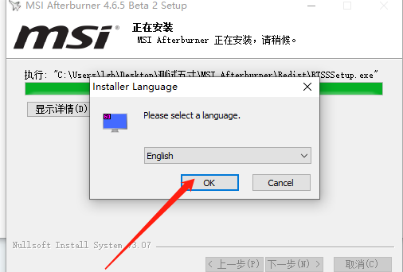

**This file is RTSS program. After clicking OK, remember the software installation location and run the software.**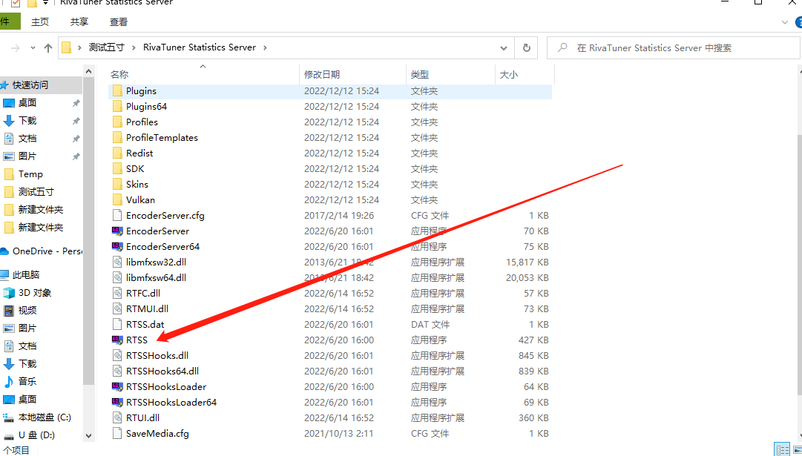

**As you can see, the small blue square appears in the lower right corner of the desktop, and open the small square.**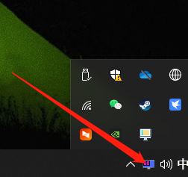

**After opening the small square, check the boot run.**

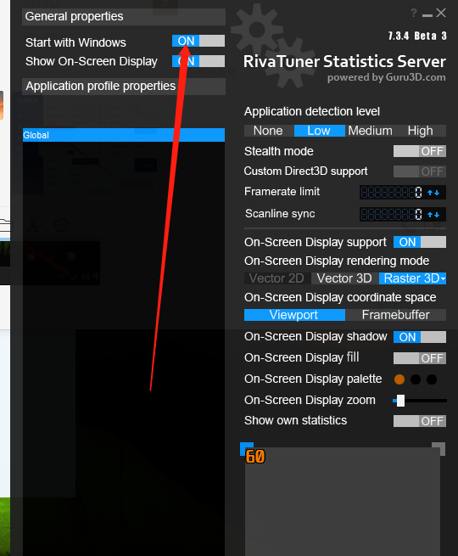

**Restart the computer, run the game, and the FPS function can be used normally.**